**Low Level Programming Report**

**Offline Editor User Manual**

Here is an image of the design of the offline editor.

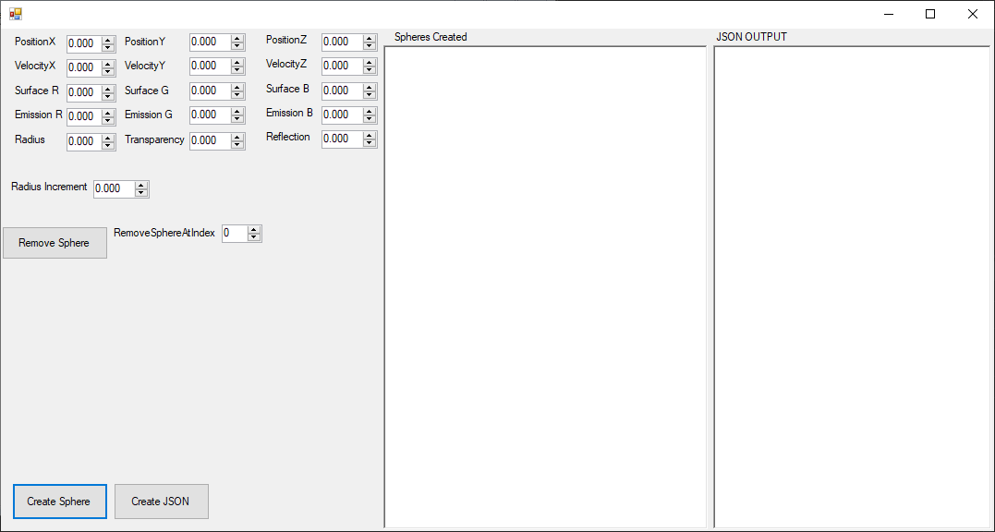

On the left-hand side are all the variables to create a sphere object. This includes animation with the Velocity and Radius Increment manipulating in which direction and if the object gets bigger or smaller in the scene. By using a single or double click number boxes or simply using the up or down arrow as shown the user can alter the values. The upper limit is 2000000 and the lower limit -2000000. There is also the option to delete the sphere with the Remove Sphere button with an index chosen by the user to the right of the button.

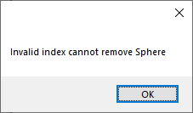

If the user provides an invalid index, the user will be notified with a pop-up window as shown above.

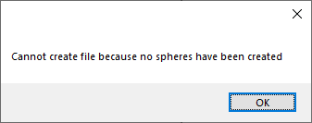

The same principle has been applied to the Create JSON button in the case that there are no spheres so there is nothing to write to.

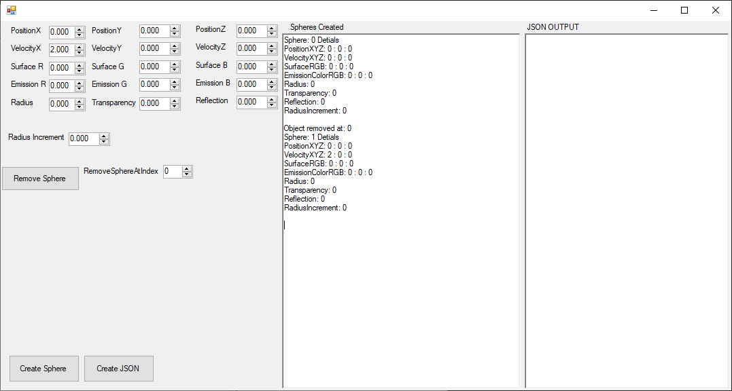

The text that is given on in the first text box shows every time you create and delete a sphere so you can check in real time and you can determine if the values you have provided and if you would like to delete and remake the object.

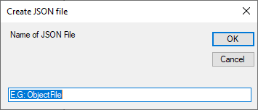

When Create JSON button is pressed the user is given this pop-up to choose a file name, json extension is not needed. This will then create and store the Json file inside of the RayTracer program.

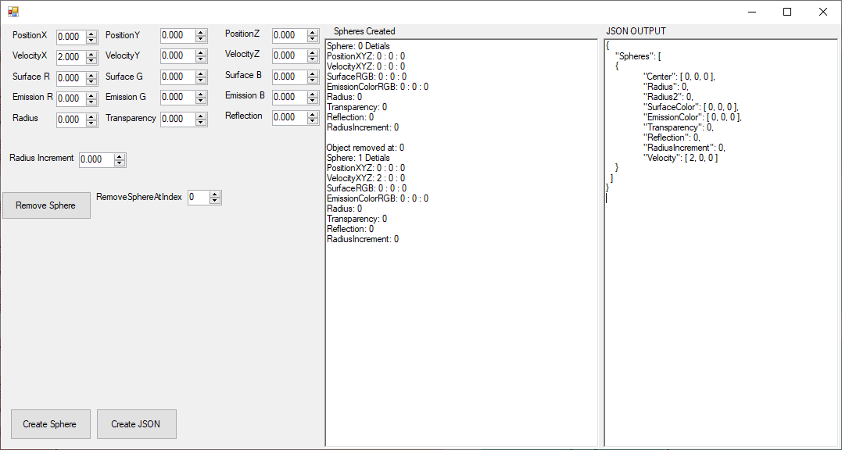

Once the user has selected the name the JSON OUPUT textbox will show you what the saved JSON looks like so the user can verify if it is what they want.

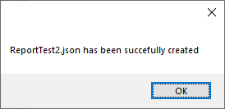

Finally, the user is given a confirmation textbox that the file has been successfully created.